Automatic report for a factorial experiment

AgroFIMS

January 07, 2021

Table of Contents

# 1. Model specification and data description

The data frame has two factors with 3 and 3 levels. The experimental design is a randomized complete block design with 2 blocks. The statistical model is

$$y_{ijk}=μ+α_{i}+β_{j}+(αβ)_{ij}+γ_{k}+ϵ_{ijk}$$

where

* $y_{ijk}$ is the observed response with level $i$ of factor A, level $j$ of factor B, and block $k$.
* $μ$ is the mean response over all levels of factor A, factor B, and blocks.
* $α_{i}$ is the effect for level $i$ of factor A.
* $β_{j}$ is the effect for level $j$ of factor B.
* $(αβ)_{ij}$ is the interaction effect between level $i$ of factor A and level $j$ of factor B.
* $γ_{k}$ is the effect of block $k$.
* $ϵ_{ijk}$ is the error term.

In this model we assume that the errors are independent and have a normal distribution with common variance, that is, $ϵ_{ijk}∼N(0,σ_{ϵ}^{2})$.

# 2. Analysis for trait barley_grain_fresh_weight_1000_grain_g

There are no missing values for this trait; the design is balanced.

## 2.1. Descriptive statistics

### 2.1.1. Means by individual factor levels

## v1 v2 v3   
## 59.00000 30.66667 52.00000   
## l1 l2 l3   
## 40.00000 55.00000 46.66667

### 2.1.2. Means by factor levels combinations

## l1 l2 l3  
## v1 19.5 87.0 70.5  
## v2 26.5 41.5 24.0  
## v3 74.0 36.5 45.5

## 2.2. ANOVA

### 2.2.1. Checking assumptions

As it was stated in section 1, it is supposed that the error has a normal distribution with the same variance for all the combinations among the levels of the factors. The following plots help to evaluate this assumptions:

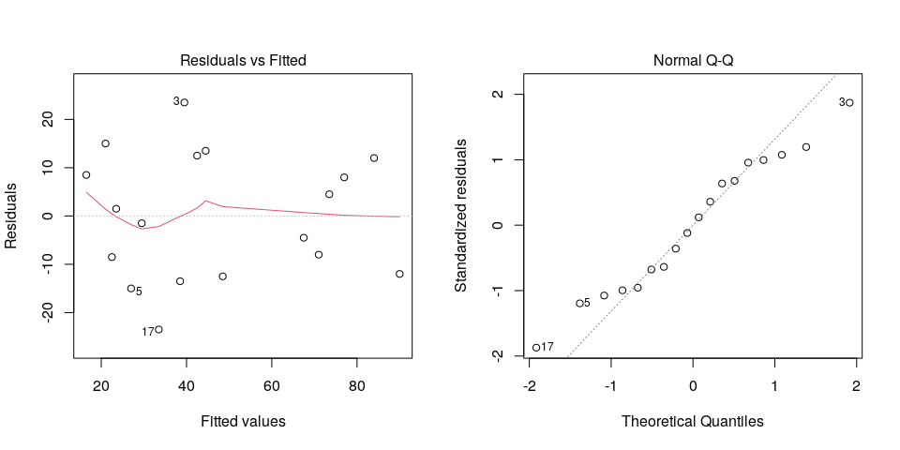

Funnel shapes for the first plot may suggest heterogeneity of variances while departures from the theoretical normal line are symptoms of lack of normality.

### 2.2.2. ANOVA table

## Analysis of Variance Table  
##   
## Response: barley_grain_fresh_weight_1000_grain_g  
## Df Sum Sq Mean Sq F value Pr(>F)   
## crop_variety1_f1 2 2613.8 1306.89 3.6853 0.07338 .  
## intercrop_row_geometry2_f2 2 677.8 338.89 0.9556 0.42447   
## block 1 162.0 162.00 0.4568 0.51817   
## crop_variety1_f1:intercrop_row_geometry2_f2 4 6166.6 1541.64 4.3472 0.03686 *  
## Residuals 8 2837.0 354.62   
## ---  
## Signif. codes: 0 '***' 0.001 '**' 0.01 '*' 0.05 '.' 0.1 ' ' 1

The coefficient of variation for this experiment is 39.88%.

# 3. Analysis for trait barley_grain_moisture_content_100_grain_percent

There are no missing values for this trait; the design is balanced.

## 3.1. Descriptive statistics

### 3.1.1. Means by individual factor levels

## v1 v2 v3   
## 55.00000 45.50000 72.66667   
## l1 l2 l3   
## 59.33333 65.50000 48.33333

### 3.1.2. Means by factor levels combinations

## l1 l2 l3  
## v1 50.5 60.5 54.0  
## v2 55.0 40.0 41.5  
## v3 72.5 96.0 49.5

## 3.2. ANOVA

### 3.2.1. Checking assumptions

As it was stated in section 1, it is supposed that the error has a normal distribution with the same variance for all the combinations among the levels of the factors. The following plots help to evaluate this assumptions:

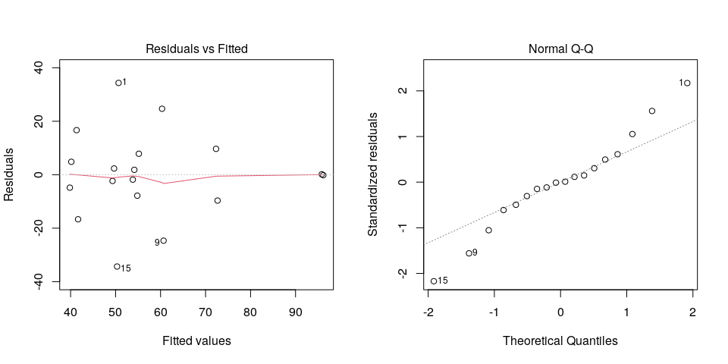

Funnel shapes for the first plot may suggest heterogeneity of variances while departures from the theoretical normal line are symptoms of lack of normality.

### 3.2.2. ANOVA table

## Analysis of Variance Table  
##   
## Response: barley_grain_moisture_content_100_grain_percent  
## Df Sum Sq Mean Sq F value Pr(>F)  
## crop_variety1_f1 2 2280.8 1140.39 2.0256 0.1942  
## intercrop_row_geometry2_f2 2 907.4 453.72 0.8059 0.4799  
## block 1 0.5 0.50 0.0009 0.9770  
## crop_variety1_f1:intercrop_row_geometry2_f2 4 1630.9 407.72 0.7242 0.5994  
## Residuals 8 4504.0 563.00

The coefficient of variation for this experiment is 41.11%.