Automatic report for a factorial experiment

AgroFIMS

January 07, 2021

Table of Contents

# 1. Model specification and data description

The data frame has two factors with 3 and 2 levels. The experimental design is a completely randomized design with 2 replications. The statistical model is

$$y_{ijk}=μ+α_{i}+β_{j}+(αβ)_{ij}+ϵ_{ijk}$$

where

* $y_{ijk}$ is the observed response with level $i$ of factor A, level $j$ of factor B, and replication $k$.
* $μ$ is the mean response over all levels of factor A, factor B, and replications.
* $α_{i}$ is the effect for level $i$ of factor A.
* $β_{j}$ is the effect for level $j$ of factor B.
* $(αβ)_{ij}$ is the interaction effect between level $i$ of factor A and level $j$ of factor B.
* $ϵ_{ijk}$ is the error term.

In this model we assume that the errors are independent and have a normal distribution with common variance, that is, $ϵ_{ijk}∼N(0,σ_{ϵ}^{2})$.

# 2. Analysis for trait chickpea_grain_fresh_weight_1000_grain_g

There are no missing values for this trait; the design is balanced.

## 2.1. Descriptive statistics

### 2.1.1. Means by individual factor levels

## v1 v2 v3   
## 59.25 63.25 79.00   
## Mixed intercropping Row intercropping   
## 70.00000 64.33333

### 2.1.2. Means by factor levels combinations

## Mixed intercropping Row intercropping  
## v1 78 40.5  
## v2 55 71.5  
## v3 77 81.0

## 2.2. ANOVA

### 2.2.1. Checking assumptions

As it was stated in section 1, it is supposed that the error has a normal distribution with the same variance for all the combinations among the levels of the factors. The following plots help to evaluate this assumptions:

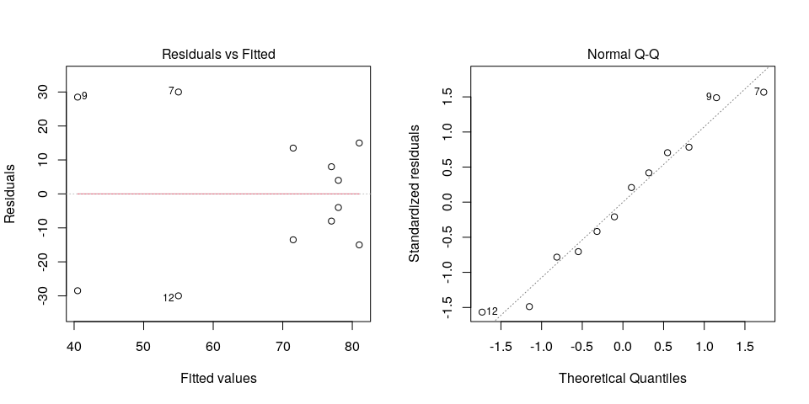

Funnel shapes for the first plot may suggest heterogeneity of variances while departures from the theoretical normal line are symptoms of lack of normality.

### 2.2.2. ANOVA table

## Analysis of Variance Table  
##   
## Response: chickpea_grain_fresh_weight_1000_grain_g  
## Df Sum Sq Mean Sq F value Pr(>F)  
## crop_variety1_f1 2 872.2 436.08 0.5948 0.5812  
## intercrop_arrangement2_f2 1 96.3 96.33 0.1314 0.7294  
## crop_variety1_f1:intercrop_arrangement2_f2 2 1598.2 799.08 1.0899 0.3947  
## Residuals 6 4399.0 733.17

The coefficient of variation for this experiment is 40.31%.

# 3. Analysis for trait chickpea_grain_subsample_fresh_weight_100_grain_g

There are no missing values for this trait; the design is balanced.

## 3.1. Descriptive statistics

### 3.1.1. Means by individual factor levels

## v1 v2 v3   
## 58.75 60.50 43.50   
## Mixed intercropping Row intercropping   
## 45.66667 62.83333

### 3.1.2. Means by factor levels combinations

## Mixed intercropping Row intercropping  
## v1 40.5 77.0  
## v2 66.0 55.0  
## v3 30.5 56.5

## 3.2. ANOVA

### 3.2.1. Checking assumptions

As it was stated in section 1, it is supposed that the error has a normal distribution with the same variance for all the combinations among the levels of the factors. The following plots help to evaluate this assumptions:

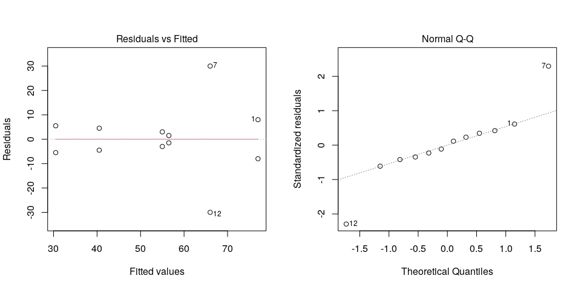

Funnel shapes for the first plot may suggest heterogeneity of variances while departures from the theoretical normal line are symptoms of lack of normality.

### 3.2.2. ANOVA table

## Analysis of Variance Table  
##   
## Response: chickpea_grain_subsample_fresh_weight_100_grain_g  
## Df Sum Sq Mean Sq F value Pr(>F)  
## crop_variety1_f1 2 699.50 349.75 1.0229 0.4147  
## intercrop_arrangement2_f2 1 884.08 884.08 2.5857 0.1590  
## crop_variety1_f1:intercrop_arrangement2_f2 2 1245.17 622.58 1.8209 0.2410  
## Residuals 6 2051.50 341.92

The coefficient of variation for this experiment is 34.08%.