Automatic report for a Completely Randomized Design (CRD)

AgroFIMS

January 06, 2021

Table of Contents

# 1. Model specification and data description

Data from 6 Treatments have been evaluated using a completely randomized design. The statistical model is

$$y_{ij}=μ+τ_{i}+ϵ_{ij}$$

where

* $y_{ij}$ is the observed response with Treatment $i$ and replication $j$.
* $μ$ is the mean response over all Treatments and replications.
* $τ_{i}$ is the effect for Treatment $i$.
* $ϵ_{ij}$ is the error term.

In this model we assume that the errors are independent and have a normal distribution with common variance, that is, $ϵ_{ij}∼N(0,σ_{ϵ}^{2})$.

# 2. Analysis for trait chickpea_grain_fresh_weight_1000_grain_g

## 2.1. Exploratory analysis

It is always good to have some visualization of your data. Below a histogram and a boxplot are shown.

# Keep a copy of full data  
mydata.full <- mydata  
# Get means for subsampling  
mydata <- st4gi::docomp("mean", trait, c(treatment, experimental.unit), dfr = mydata)

par(mfrow = c(1, 2))  
hist(mydata$trait)  
boxplot(mydata$trait)

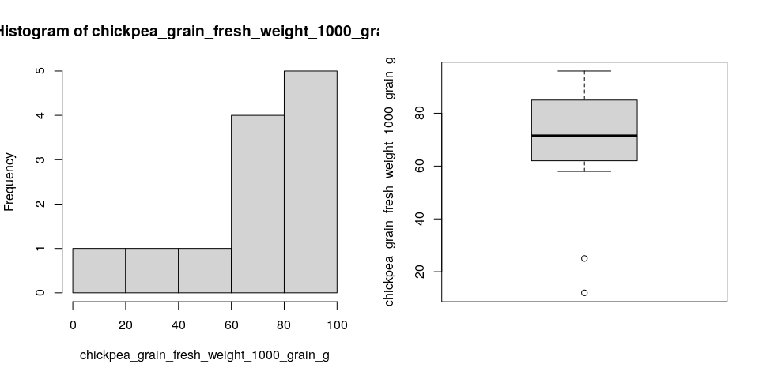

Since the number of Treatments in your experiment is not so large, we can plot the data for each Treatment:

st4gi::msdplot(trait, treatment, mydata, conf = 1, pch = 4)

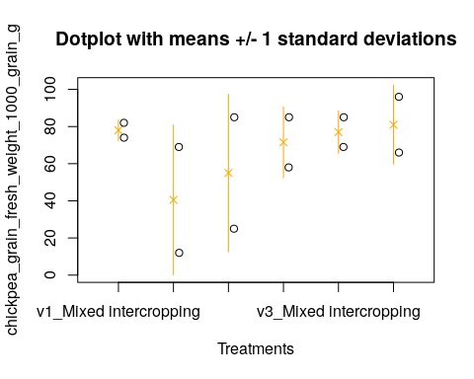

## 2.2. ANOVA

You have fitted a linear model for a CRD. The ANOVA table for your model is:

model <- aov(trait ~ treatment, data = mydata)  
# Anova table  
at <- anova(model)  
at

Analysis of Variance Table  
  
Response: "chickpea_grain_fresh_weight_1000_grain_g"  
 Df Sum Sq Mean Sq F value Pr(>F)  
treatment 5 2566.7 513.33 0.7002 0.6437  
Residuals 6 4399.0 733.17

The coefficient of variation for this experiment is 40.31%. The p-value for Treatments is 0.6437 which is not significant at the 5% level.

## 2.3. Assumptions

Don’t forget the assumptions of the model. It is supposed that the errors are independent with a normal distribution and with the same variance for all the Treatments. The following residuals plots can help you evaluate this:

par(mfrow = c(1, 2))  
plot(model, which = 1)  
plot(model, which = 2)

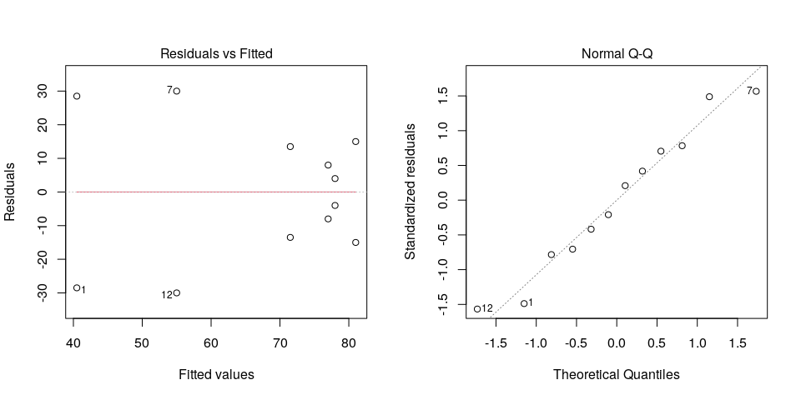

Any trend in the residuals in the left plot would violate the assumption of independence while a trend in the variability of the residuals –for instance a funnel shape– suggests heterogeneity of variances. Deviation from the theoretical normal line on the right plot is a sign of lack of normality.

## 2.4. Treatment means

Because the effect of Treatments was not significant in the ANOVA, multiple comparison tests are not presented. The means of your Treatments are:

tapply(mydata$trait, mydata$treatment, mean, na.rm = TRUE)

v1_Mixed intercropping v1_Row intercropping v2_Mixed intercropping   
 78.0 40.5 55.0   
 v2_Row intercropping v3_Mixed intercropping v3_Row intercropping   
 71.5 77.0 81.0

## 2.5. Variance components

Below are the variance components for this model, under the assumption that Treatments are random. Here the model is fitted using REML.

model <- lme4::lmer(trait ~ (1|treatment), data = mydata)  
vc <- data.frame(lme4::VarCorr(model))  
vc[, c(1, 4, 5)]

boundary (singular) fit: see ?isSingular

Variance Std.Dev.  
treatment 0.0000 0.00000  
Residual 633.2424 25.16431