Automatic report for a Randomized Complete Block Design (RCBD)

AgroFIMS

January 06, 2021

Table of Contents

# 1. Model specification and data description

Data from 4 Treatments have been evaluated using a randomize complete block design with 2 blocks. The statistical model is

$$y_{ij}=μ+τ_{i}+β_{j}+ϵ_{ij}$$

where

* $y_{ij}$ is the observed response with Treatment $i$ and block $j$.
* $μ$ is the mean response over all Treatments and blocks.
* $τ_{i}$ is the effect for Treatment $i$.
* $β_{j}$ is the effect for block $j$.
* $ϵ_{ij}$ is the error term.

In this model we assume that the errors are independent and have a normal distribution with common variance, that is, $ϵ_{ij}∼N(0,σ_{ϵ}^{2})$.

# 2. Analysis for trait rice_grain_moisture_content_1000_grain_percent_1

## 2.1. Exploratory analysis

It is always good to have some visualization of your data. Below a histogram and a boxplot are shown.

# Keep a copy of full data  
mydata.full <- mydata  
# Get means for subsampling  
mydata <- st4gi::docomp("mean", trait, c(treatment, experimental.unit), rep, mydata)

par(mfrow = c(1, 2))  
hist(mydata$trait)  
boxplot(mydata$trait)

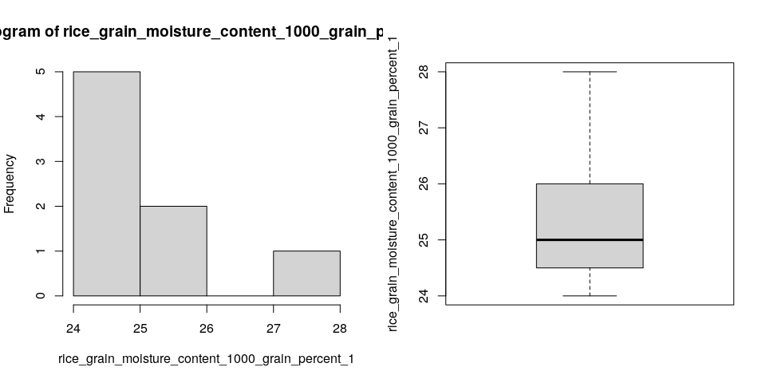

Since the number of Treatments in your experiment is not so large, we can plot the data for each Treatment:

st4gi::msdplot(trait, treatment, mydata, conf = 1, pch = 4)

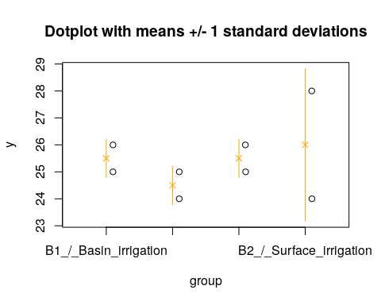

## 2.2. ANOVA

You have fitted a linear model for a RCBD. The ANOVA table for your model is:

at <- aov.rcbd(trait, treatment, rep, mydata)  
# Anova table  
at

Analysis of Variance Table  
  
Response: "rice_grain_moisture_content_1000_grain_percent_1"  
 Df Sum Sq Mean Sq F value Pr(>F)  
treatment 3 2.375 0.79167 0.2836 0.8359  
block 1 1.125 1.12500 0.4030 0.5707  
Residuals 3 8.375 2.79167

The coefficient of variation for this experiment is 6.585%. The p-value for Treatments is 0.8359 which is not significant at the 5% level.

## 2.3. Assumptions

Don’t forget the assumptions of the model. It is supposed that the errors are independent with a normal distribution and with the same variance for all the Treatments. The following plots can help you evaluate this:

par(mfrow = c(1, 2))  
plot(model, which = 1)  
plot(model, which = 2)

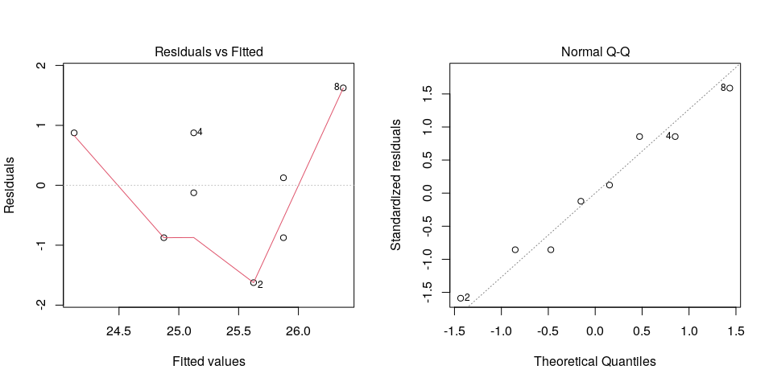

Any trend in the residuals in the left plot would violate the assumption of independence while a trend in the variability of the residuals –for instance a funnel shape– suggests heterogeneity of variances. Departures from the theoretical normal line on the right plot are symptoms of lack of normality.

## 2.4. Treatment means

Because the effect of Treatments was not significant in the ANOVA, multiple comparison tests are not presented. The means of your Treatments are:

tapply(mydata$trait.est, mydata$treatment, mean, na.rm = TRUE)

B1_/_Basin_irrigation B1_/_Surface_irrigation B2_/_Border_irrigation   
 25.5 24.5 25.5   
B2_/_Surface_irrigation   
 26.0

## 2.5. Variance components

Below are the variance components for this model, under the assumption that Treatments and blocks are random. Here the model is fitted using REML and missing values are not estimated.

model <- lme4::lmer(trait ~ (1|treatment) + (1|rep), data = mydata)  
vc <- data.frame(lme4::VarCorr(model))  
vc[, c(1, 4, 5)]

boundary (singular) fit: see ?isSingular

Variance Std.Dev.  
treatment 0.000000 0.00000  
block 0.000000 0.00000  
Residual 1.696429 1.30247